

Design Document

UpliftEd - Online Learning Platform


Version | Date | Author | Changes | State
1.0 | 25/03/2025 | Georgi Ivanov | Document Creation | Draft

1. Project Overview
This project is an online learning platform where students can enroll in courses, access learning materials, take quizzes, and track progress. Teachers can create courses, upload materials, and assess student performance. The platform follows a layered architecture with a separate backend and frontend.
2. Technology Stack
The following technologies were chosen based on project requirements and practicality:
Backend: Spring Boot
- Reason: Provides a structured way to build RESTful APIs and includes built-in dependency injection, security features, and database integration.
- Why not another framework?
  - Django (Python) – Requires different ecosystem; project is Java-based.
  - Node.js – More suited for event-driven applications; Spring Boot offers better structure for enterprise-grade applications.
Frontend: React
- Reason: Uses component-based structure, improves performance with Virtual DOM, and integrates well with REST APIs.
- Why not Angular or Vue?
  - Angular – Heavy for small-scale applications.
  - Vue – Lacks enterprise-level adoption compared to React.
Database: MySQL
- Reason: Handles relational data efficiently, integrates well with Spring Boot via JPA, and is widely used in production systems.
- Why not PostgreSQL or NoSQL?
  - PostgreSQL – Similar to MySQL but slightly heavier.
  - NoSQL (MongoDB) – Not suitable as data is relational (users, courses, enrollments).
Other Technologies Used:
- JWT Authentication – Stateless authentication, allows scalability.
- Docker – Ensures that the application runs consistently across different environments.
- Git & GitLab – Version control and CI/CD management.
3. Architecture Constraints
- Scalability:
  - Must handle at least 100 concurrent users.
  - API endpoints should be stateless to allow horizontal scaling.
- Security:
  - User authentication via JWT tokens.
  - Passwords are hashed using BCrypt.
  - Role-based access control should prevent unauthorized actions.
- Maintainability:
  - The backend follows a 3-layered architecture (Controller → Service → Repository).
  - Code should be modular, following SOLID principles.
- Performance:
  - API response time should be under 500ms.
  - Queries should use proper indexing to improve retrieval speed.
- Deployment:
  - The backend runs inside a Docker container.
  - The frontend should be hosted separately and communicate with the backend via REST APIs.
4. Design Decisions

4.1 C1 Model - System Context Diagram
This diagram shows the overall system and how it interacts with external entities like users and external services.
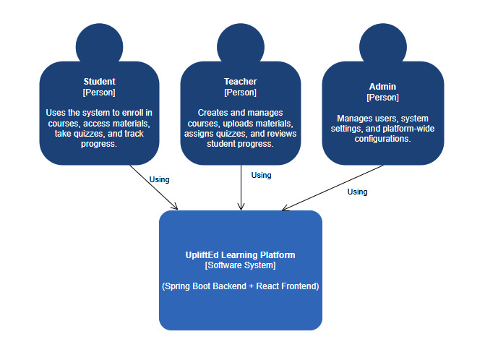
- System: Online Learning Platform
- Actors:
  - Students (Register, login, enroll in courses, track progress)
  - Teachers (Create courses, upload materials, assess students)
  - Admin (Manage platform, user permissions)
- Interactions:
  - Students/Teachers communicate with the backend via RESTful APIs.
  - Backend accesses the MySQL Database for data storage and retrieval.

4.2 C2 Model - Container Diagram
The container diagram illustrates the high-level architecture of the system showing major software containers and their interactions.
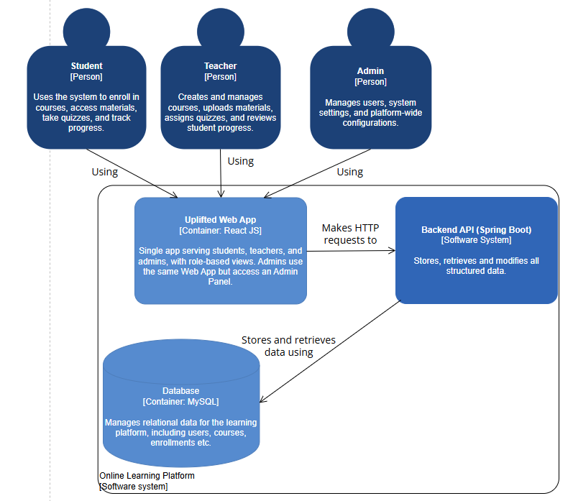
- Frontend (React):
  - Communicates with the backend via HTTP requests (Axios).
  - Displays pages like Home, Courses, Login, Register, and Course Details.
- Backend (Spring Boot):
  - Handles HTTP requests, processes data, and communicates with the database.
  - Contains controllers, services, and repositories.
  - Uses JWT Authentication for user management.
- Database (MySQL):
  - Stores data related to users, courses, enrollments, and course progress.
  - Uses JPA/Hibernate for data access.

4.3 C3 Model - Component Diagram
The component diagram breaks down the backend system into individual components and their interactions.
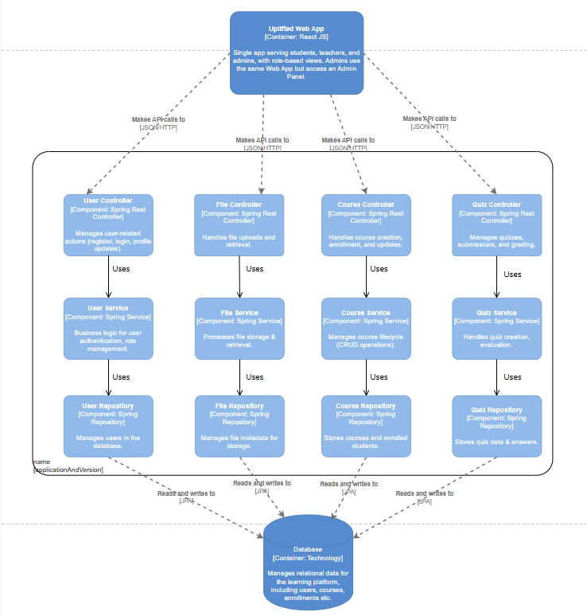

5. Software Principles Applied
SOLID Principles:
- Single Responsibility Principle: Each class has a clear responsibility (e.g., UserService only handles user-related logic).
- Open/Closed Principle: System is designed to allow new features without modifying existing core logic.
- Liskov Substitution Principle: Interfaces and abstract classes are used to ensure interchangeable implementations.
- Interface Segregation Principle: Different services (UserService, CourseService) separate concerns.
- Dependency Inversion Principle: Spring Boot’s dependency injection reduces tight coupling.
Other Software Principles:
- KISS (Keep It Simple, Stupid): Avoiding unnecessary complexity in code and architecture.
- DRY (Don't Repeat Yourself): Reusing service methods and components to reduce redundancy.
- YAGNI (You Ain’t Gonna Need It): Avoiding over-engineering and adding only essential features.

